IT24101987

Ps lab 6

Exercise

1.)

i.)

ii)

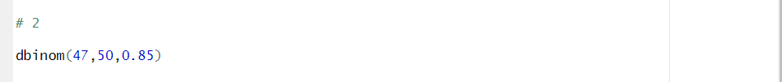



2.)

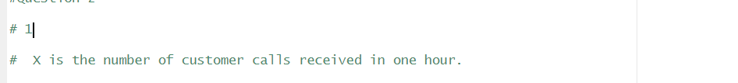 i.)

 ii.)

 iii.)

